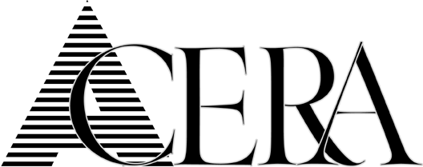

Notice

Actuarial Committee

Meeting

for

Wednesday, October 11, 2017

is

CANCELLED

